
Excellent Location

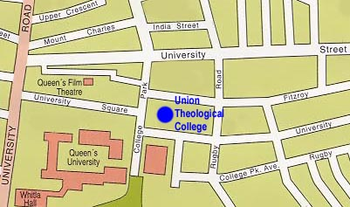
At the top of Botanic avenue in the heart of the university area.

Within a short walking distance of

- Queen’s University Campus
- Excellent local Churches
- Botanic train station
- Regular Metro service
- Local shops for all your needs
- Selection of wonderful cuisine
- Belfast Botanical Gardens

The College operates No Smoking, No Drugs, No Alcohol & No Vaping policies.
Accommodation at Union
2022-23
Student
Accommodation

Modern student accommodation in the heart of the university quarter
Rooms
- Single with en suite
- Study area
- Telephone
- Self-catering
- Wireless internet access
- Central heating

Shared Kitchen

- Cooker
- Microwave
- Fridge space
- Freezer space
- Store cupboard
- Television

You Provide

- Kitchen utensils
- Cutlery
- Pillow, duvet and duvet cover
- Sheets and pillow case

Common Room

On the ground floor:

- Comfy seating
- Pool table
- 40" Television

Laundry Room

- Washing machine
- Drier
- Iron and
ironing board
- Vacuum cleaner

Card System

- Photocopying
- Printing

Fees 2022-23
Our aim is to create a residential community with a specific Christian ethos

Booking deposit: £200
(also functions as a damage deposit)

Room fees per week: £112
(£4,144 for 37 weeks)

In the event of loss or damage:
Replacement key: £15

Other details

Residential year: 37 weeks
17 Sept 2022 – 2 June 2023

Payment method: 2 equal amounts
First week in October & February
(or as arranged with Accommodation
Coordinator)
How to apply

Application Forms are available
from the college (see contact details below).

Accommodation Coordinator
Union Theological College
108 Botanic Avenue
Belfast, BT7 1JT

Telephone: 028 9020 5080
Email:
accommodation@union.ac.uk

Completed forms should be returned to the College ideally by Friday 29 July 2022.


Have a

You are welcome to come and see the rooms. To arrange a suitable time please contact the Accommodation
Coordinator (as above).

